Curriculum Vitae
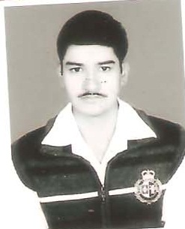

SONU KUMAR
S/o Sri Rakesh Kumar
KUNDA,KARNIBAGH
Dist-B.Deoghar-814112
State-Jharkhand
È- 08092061581
e-mail :- sonu7551@gmail.com

Objective To work in an organization where I can best utilize my skills to
deliver results and best services.

Educational
Qualification : Intermediate

IT Skills Windows, MS Office, Programming Languages- C, C++, Java,
VB.Net, Database- MS Access,
Oracle, Scripting language –HTML, Java Script .

IT Qualification: APPEARING BCA from SMU through ZHI,DEOGHAR.

Personal ● Date of Birth 15th Feb 1994.
Detail ● Sex Male.
● Marital Status Unmarried.

Language English, Hindi .

Nationality Indian

Religion Hindu

I Sonu Kumar do hereby declare that all the information given in the CV above is true and correct to the best of my knowledge and belief.

Date: 20-08-2015
`
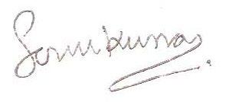

Sonu Kumar

